**WITH NOISE AND WITH FILTER**

**Image set:**

|  |
| --- |
| **Image 1:-0.1 % Noise** |

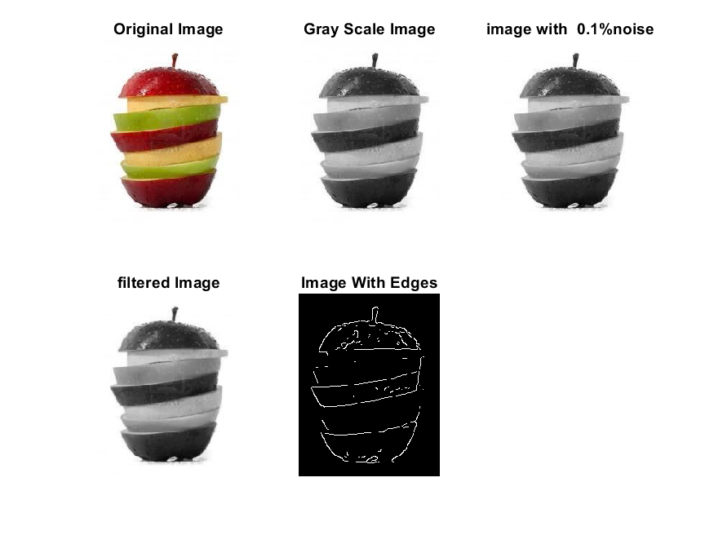

**Image 2:-10 % Noise**

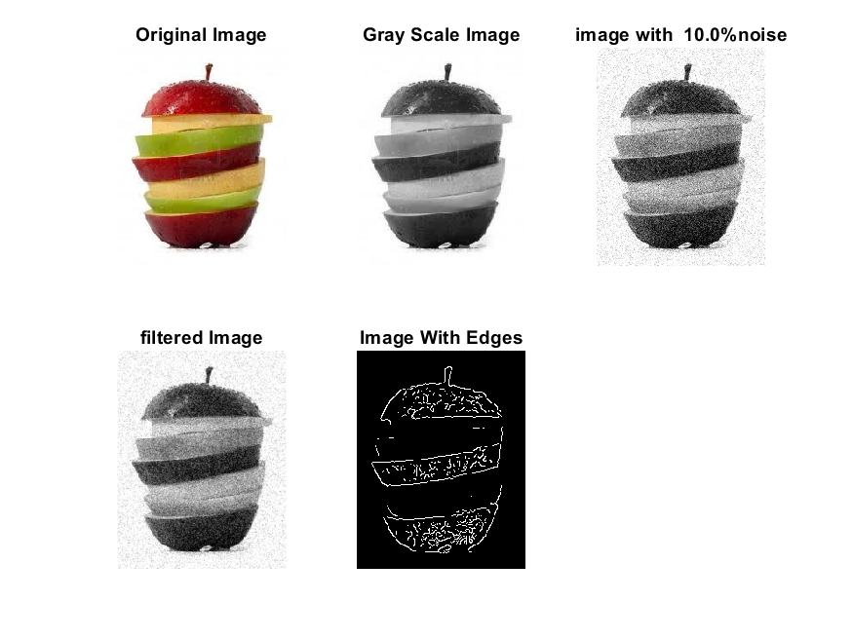

**Image 3:-20 % Noise**

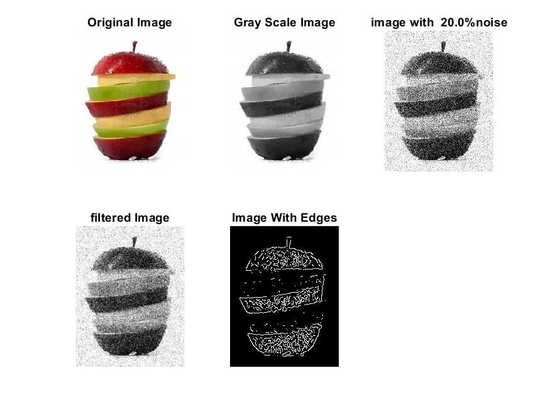

**Image 4:-30 % Noise**

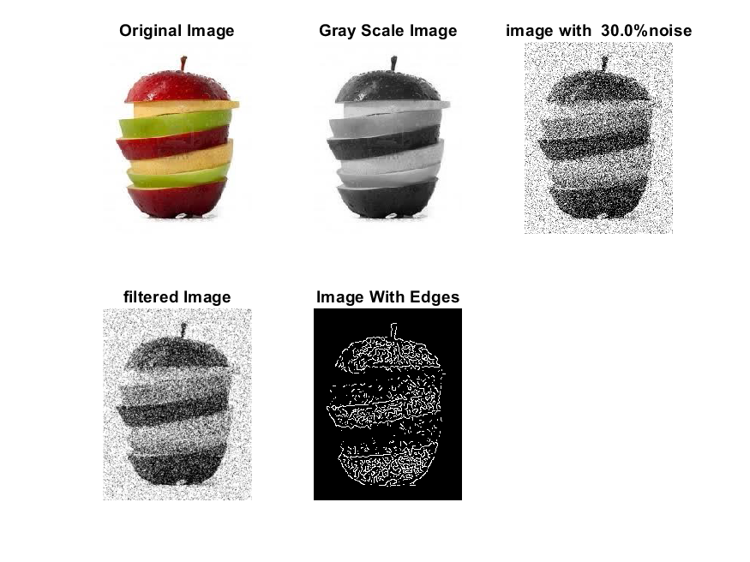

|  |
| --- |
| **Image 5:-40 % Noise** |

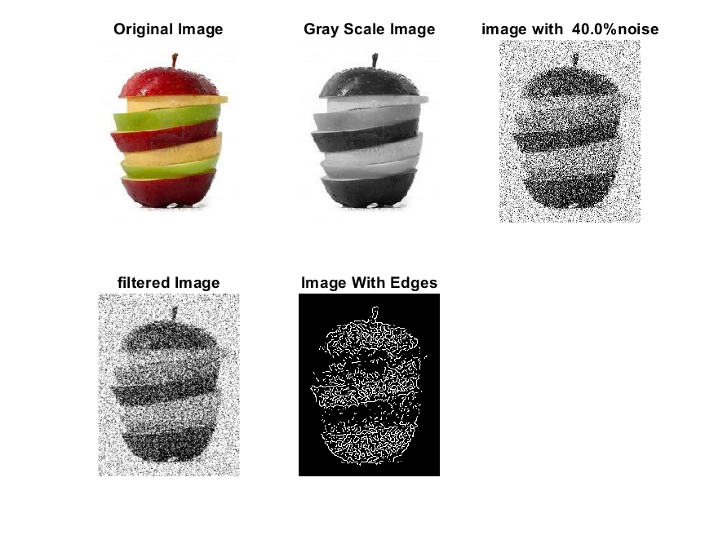

**Image 6:-50 % Noise**

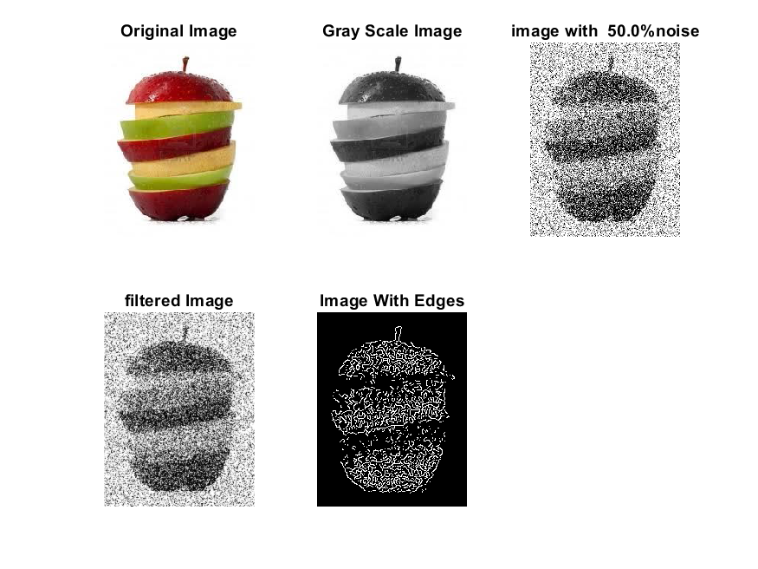

**Image 7:-60 % Noise**

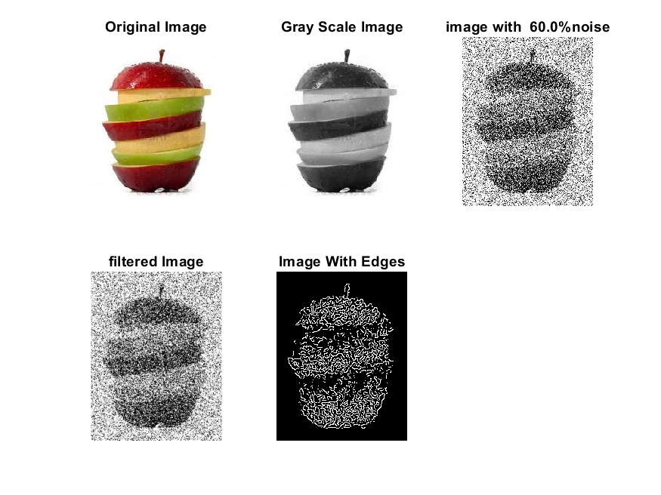

**Image 8:-70 % Noise**

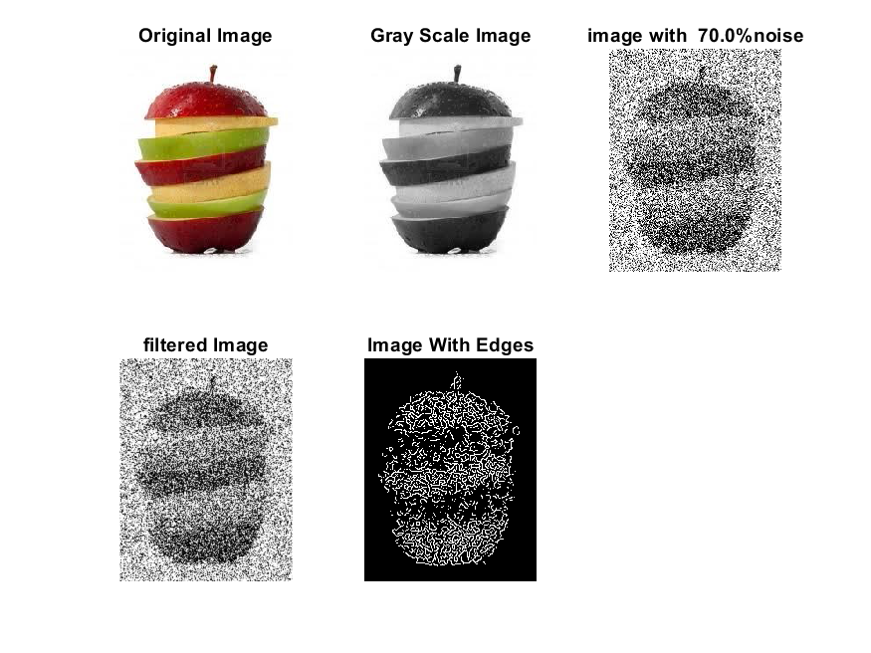

**Image 9:-80 % Noise**

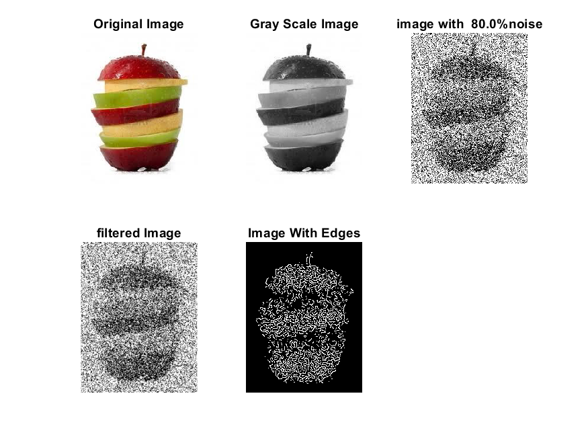

**DATA FILES**

**Image 1:-Noise0.1**

Original image ideal values:

IM1 image entropy:1.960812e-01

IM1 image mean:0.030337

Ground truth image entropy:0.596365

Ground truth image mean:0.144680

entropy between imt and im1 :0.567745

MSE between imt and im1 :0.153240

Average Difference between imt and im1 :0.114343

Maximum Difference between imt and im1 :1.000000

True Positive values:547.000000

False Positive values: 977.000000

True Negative values:41990.000000

False Negative values:6721.000000

Accuracy value: 0.846760

F Measure values:0.124431

Peak Signal-to Noise Ration value: 8.146285

Signal-to Noise Ration value: -6.784300

percentage of pixels that were correctly detected (Pco): 0.075261

The percentage of pixels that were not detected (Pnd):0.924739

the percentage of false alarm: (Pfa):0.134425 Euclidean Distance Value :6.666877

**Image 2:-Noise10**

Original image ideal values:

IM1 image entropy:2.886126e-01

IM1 image mean:0.050523

Ground truth image entropy:0.596365

Ground truth image mean:0.144680

entropy between imt and im1 :0.558989

MSE between imt and im1 :0.166975

Average Difference between imt and im1 :0.094157

Maximum Difference between imt and im1 :1.000000

True Positive values:709.000000

False Positive values: 1829.000000

True Negative values:41138.000000

False Negative values:6559.000000

Accuracy value: 0.833025

F Measure values:0.144605

Peak Signal-to Noise Ration value: 7.773480

Signal-to Noise Ration value: -4.569233

percentage of pixels that were correctly detected (Pco): 0.097551

The percentage of pixels that were not detected (Pnd):0.902449

the percentage of false alarm: (Pfa):0.251651

Euclidean Distance Value :8.860923

**Image 3:-Noise20**

Original image ideal values:

IM1 image entropy:3.894404e-01

IM1 image mean:0.076421

Ground truth image entropy:0.596365

Ground truth image mean:0.144680

entropy between imt and im1 :0.540068

MSE between imt and im1 :0.179257

Average Difference between imt and im1 :0.068259

Maximum Difference between imt and im1 :1.000000

True Positive values:1051.000000

False Positive values: 2788.000000

True Negative values:40179.000000

False Negative values:6217.000000

Accuracy value: 0.820743

F Measure values:0.189250

Peak Signal-to Noise Ration value: 7.465227

Signal-to Noise Ration value: -2.771968

percentage of pixels that were correctly detected (Pco): 0.144606

The percentage of pixels that were not detected (Pnd):0.855394

the percentage of false alarm: (Pfa):0.383599

Euclidean Distance Value :13.532794

**Image 4:-Noise30**

Original image ideal values:

IM1 image entropy:4.596824e-01

IM1 image mean:0.097084

Ground truth image entropy:0.596365

Ground truth image mean:0.144680

entropy between imt and im1 :0.525734

MSE between imt and im1 :0.189888

Average Difference between imt and im1 :0.047596

Maximum Difference between imt and im1 :1.000000

True Positive values:1303.000000

False Positive values: 3574.000000

True Negative values:39393.000000

False Negative values:5965.000000

Accuracy value: 0.810112

F Measure values:0.214574

Peak Signal-to Noise Ration value: 7.215036

Signal-to Noise Ration value: -1.732622

percentage of pixels that were correctly detected (Pco): 0.179279

The percentage of pixels that were not detected (Pnd):0.820721

the percentage of false alarm: (Pfa):0.491745

Euclidean Distance Value :16.987246

**Image 5:-Noise40**

Original image ideal values:

IM1 image entropy:5.191357e-01

IM1 image mean:0.116473

Ground truth image entropy:0.596365

Ground truth image mean:0.144680

entropy between imt and im1 :0.511465

MSE between imt and im1 :0.199522

Average Difference between imt and im1 :0.028207

Maximum Difference between imt and im1 :1.000000

True Positive values:1548.000000

False Positive values: 4303.000000

True Negative values:38664.000000

False Negative values:5720.000000

Accuracy value: 0.800478

F Measure values:0.235994

Peak Signal-to Noise Ration value: 7.000087

Signal-to Noise Ration value: -0.941848

percentage of pixels that were correctly detected (Pco): 0.212988

The percentage of pixels that were not detected (Pnd):0.787012

the percentage of false alarm: (Pfa):0.592047

Euclidean Distance Value :20.347763

**Image 6:-Noise50**

Original image ideal values:

IM1 image entropy:5.363470e-01

IM1 image mean:0.122445

Ground truth image entropy:0.596365

Ground truth image mean:0.144680

entropy between imt and im1 :0.505305

MSE between imt and im1 :0.201354

Average Difference between imt and im1 :0.022235

Maximum Difference between imt and im1 :1.000000

True Positive values:1652.000000

False Positive values: 4499.000000

True Negative values:38468.000000

False Negative values:5616.000000

Accuracy value: 0.798646

F Measure values:0.246218

Peak Signal-to Noise Ration value: 6.960405

Signal-to Noise Ration value: -0.724692

percentage of pixels that were correctly detected (Pco): 0.227298

The percentage of pixels that were not detected (Pnd):0.772702

the percentage of false alarm: (Pfa):0.619015

Euclidean Distance Value :21.773267

**Image 7:-Noise60**

Original image ideal values:

IM1 image entropy:5.588804e-01

IM1 image mean:0.130527

Ground truth image entropy:0.596365

Ground truth image mean:0.144680

entropy between imt and im1 :0.505008

MSE between imt and im1 :0.209237

Average Difference between imt and im1 :0.014153

Maximum Difference between imt and im1 :1.000000

True Positive values:1657.000000

False Positive values: 4900.000000

True Negative values:38067.000000

False Negative values:5611.000000

Accuracy value: 0.790763

F Measure values:0.239711

Peak Signal-to Noise Ration value: 6.793624

Signal-to Noise Ration value: -0.447097

percentage of pixels that were correctly detected (Pco): 0.227986

The percentage of pixels that were not detected (Pnd):0.772014

the percentage of false alarm: (Pfa):0.674188

Euclidean Distance Value :21.848790

**Image 8:-Noise70**

Original image ideal values:

IM1 image entropy:5.561511e-01

IM1 image mean:0.129531

Ground truth image entropy:0.596365

Ground truth image mean:0.144680

entropy between imt and im1 :0.500645

MSE between imt and im1 :0.205335

Average Difference between imt and im1 :0.015149

Maximum Difference between imt and im1 :1.000000

True Positive values:1730.000000

False Positive values: 4777.000000

True Negative values:38190.000000

False Negative values:5538.000000

Accuracy value: 0.794665

F Measure values:0.251180

Peak Signal-to Noise Ration value: 6.875372

Signal-to Noise Ration value: -0.480341

percentage of pixels that were correctly detected (Pco): 0.238030

The percentage of pixels that were not detected (Pnd):0.761970

the percentage of false alarm: (Pfa):0.657265

Euclidean Distance Value :22.845110

**Image 9:-Noise80**

Original image ideal values:

IM1 image entropy:5.701001e-01

IM1 image mean:0.134667

Ground truth image entropy:0.596365

Ground truth image mean:0.144680

entropy between imt and im1 :0.494558

MSE between imt and im1 :0.206450

Average Difference between imt and im1 :0.010013

Maximum Difference between imt and im1 :1.000000

True Positive values:1831.000000

False Positive values: 4934.000000

True Negative values:38033.000000

False Negative values:5437.000000

Accuracy value: 0.793550

F Measure values:0.260956

Peak Signal-to Noise Ration value: 6.851858

Signal-to Noise Ration value: -0.311471

percentage of pixels that were correctly detected (Pco): 0.251926

The percentage of pixels that were not detected (Pnd):0.748074

the percentage of false alarm: (Pfa):0.678866

Euclidean Distance Value :24.237751